Lecture 1: Introduction to the Engineering Profession

What is engineering?
The engineering profession is a field that uses scientific principles to design, build, and maintain structures, systems, machines, and processes. Engineers are problem solvers who focus on improving lives by applying practical knowledge of science and mathematics. They work in various sectors, such as construction, IT, transportation, healthcare, and energy.

Importance of Engineering in Society
Engineering is fundamental to modern life. It contributes to the development of infrastructure, the advancement of technology, and environmental protection. Engineers work on everything from designing buildings and bridges to creating clean energy solutions and medical devices. They ensure that systems and products are safe, efficient, and sustainable.

Branches of Engineering
There are many specializations in the field of engineering, each focusing on different problems. Some of the key branches include:
- Civil Engineering: Focuses on designing and constructing infrastructure like bridges, roads, and buildings. For example, civil engineers worked on the Golden Gate Bridge, one of the world’s most famous bridges.
- Mechanical Engineering: Involves designing machines and mechanical systems, such as engines or HVAC systems. A real-life example is the design of car engines to improve fuel efficiency.
- Electrical Engineering: Deals with the design of electrical systems, circuits, and electronic devices. A smartphone is a product of electrical engineering, where engineers design the circuit board and communication systems.
- Software Engineering: Focuses on designing, developing, and maintaining software applications. Mobile apps like WhatsApp and Instagram are examples of software engineering applications.
- Environmental Engineering: Involves projects related to the environment, like water treatment, waste management, and pollution control. Water treatment plants are an example of this type of engineering, as they help make water safe to drink.

Role of Engineers in Society
Engineers have a huge impact on society, improving everyday life in many ways. They design and build:
- Infrastructure: Roads, bridges, tunnels, and airports that people use daily.
- Technology: Devices such as smartphones, computers, and renewable energy systems that are essential in modern life.
- Environmental Protection: Engineers help design systems to clean water, manage waste, and prevent pollution.

Key Aspects of Engineering

Key Skills and Responsibilities of Engineers
While engineering is rooted in science, it also requires creativity, problem-solving skills, and an understanding of societal needs. Engineers must:
- Solve Complex Problems: Engineers use their knowledge to solve real-world problems. For instance, designing a new bridge requires solving challenges like weight distribution, material selection, and environmental impact.
- Innovate and Create: Engineers continuously innovate to create new products and systems. For example, designing solar-powered cars requires engineers to combine knowledge of electronics, energy storage, and sustainable materials.
- Adhere to Ethics and Standards: Engineering is a profession that has a significant impact on people and the environment. Engineers follow ethical standards to ensure that their designs do not harm people or the planet. There are codes of conduct like the IEEE Code of Ethics and ACM Code of Ethics to guide engineers in making responsible decisions.

Example: Engineering in Real Life – The Bridge
Consider the example of building a bridge:
- Problem: A city needs to connect two areas separated by a river.
- Solution: A civil engineer designs a bridge that can carry cars, trucks, and pedestrians safely.
Process:
- Surveying: The engineer surveys the river, its depth, width, and flood risk.
- Designing: Using CAD software, the engineer designs the bridge, selecting materials like steel or concrete.
- Construction: Workers build the bridge based on the engineer's design.
- Testing: The bridge is tested to ensure it can handle traffic and weather conditions.
This is an example of how engineers solve real-world challenges by applying scientific knowledge and creative thinking.

Figure: Bridge Design Process

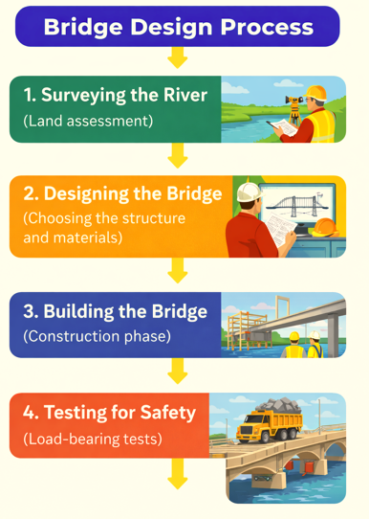

- Surveying the River (Land assessment)
- Designing the Bridge (Choosing the structure and materials)
- Building the Bridge (Construction phase)
- Testing for Safety (Load-bearing tests)
The engineering profession is vast and involves addressing real-world problems by applying scientific and mathematical principles. Engineers work across various fields to improve infrastructure, technology, and the environment, and they play an essential role in shaping the future. By ensuring safe, efficient, and sustainable solutions, engineers contribute significantly to societal development.

